Alegayter Sails Symmetrical Spinnaker Measurement Form
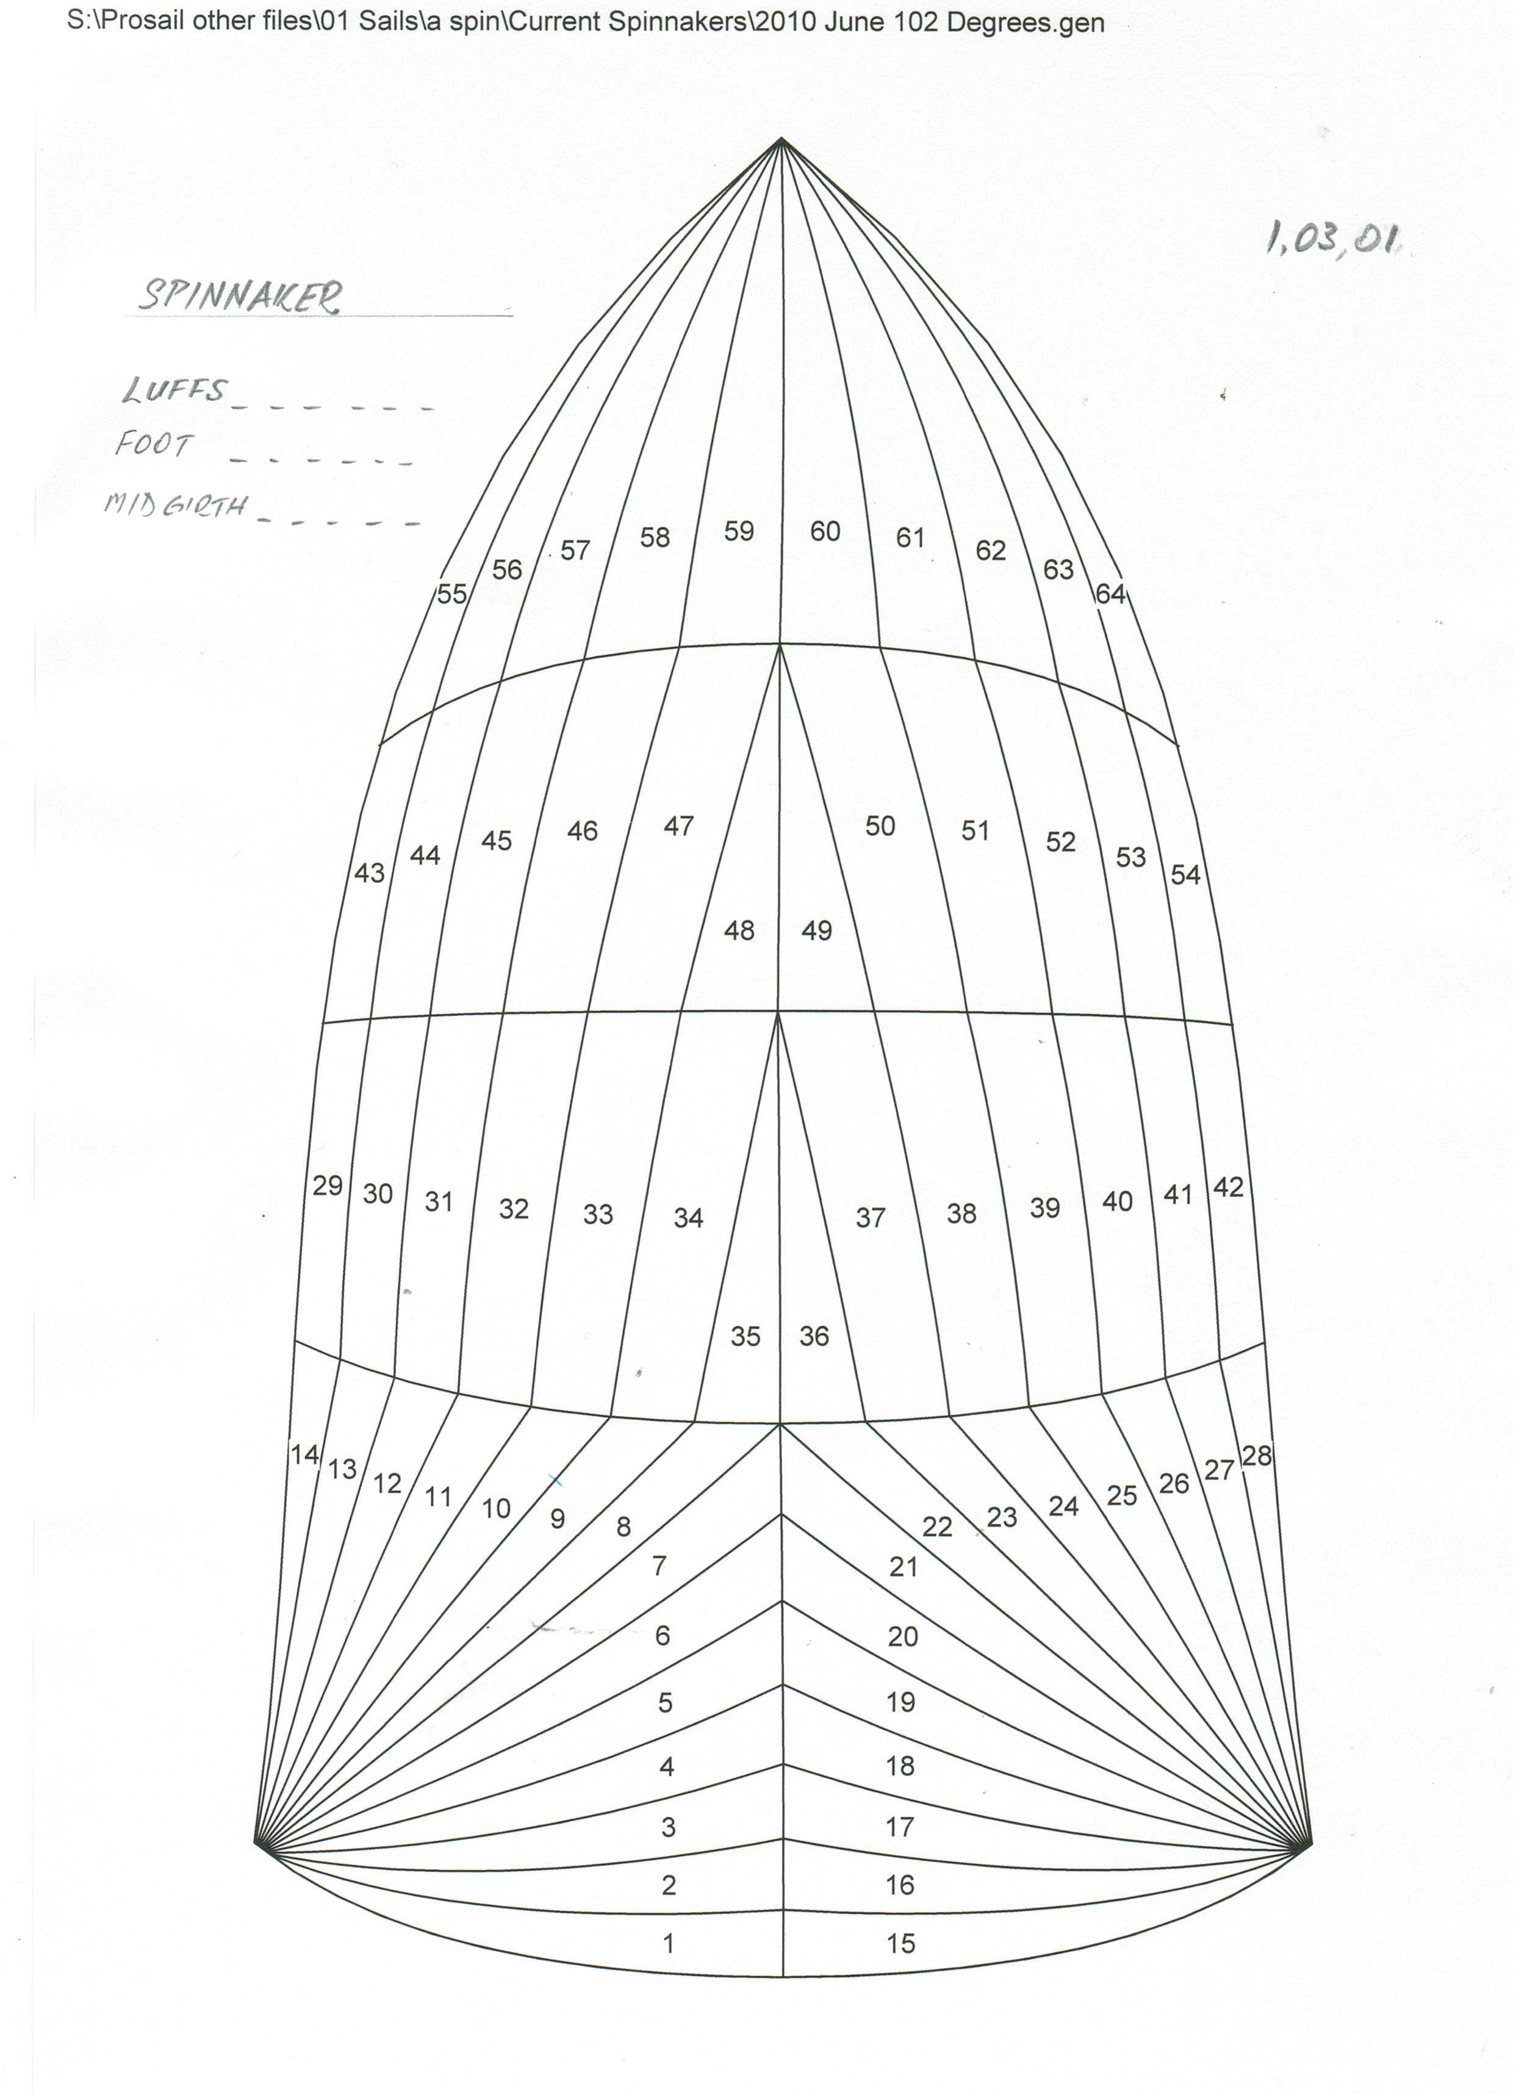
Alegayter Sails Symmetrical Spinnaker Measurement Form

Name: __________________________________________

Tel: ____________________________________________

Mob: ___________________________________________

Email: __________________________________________

This is for: QUOTE or ORDER (please circle)

Please fax this to us on (08) 8241 0889

OR

Email this as an attachment to us at mail@alegayter.com.au

