Alegayter Sails Tri-radial Cross-cut Headsail Measurement Form
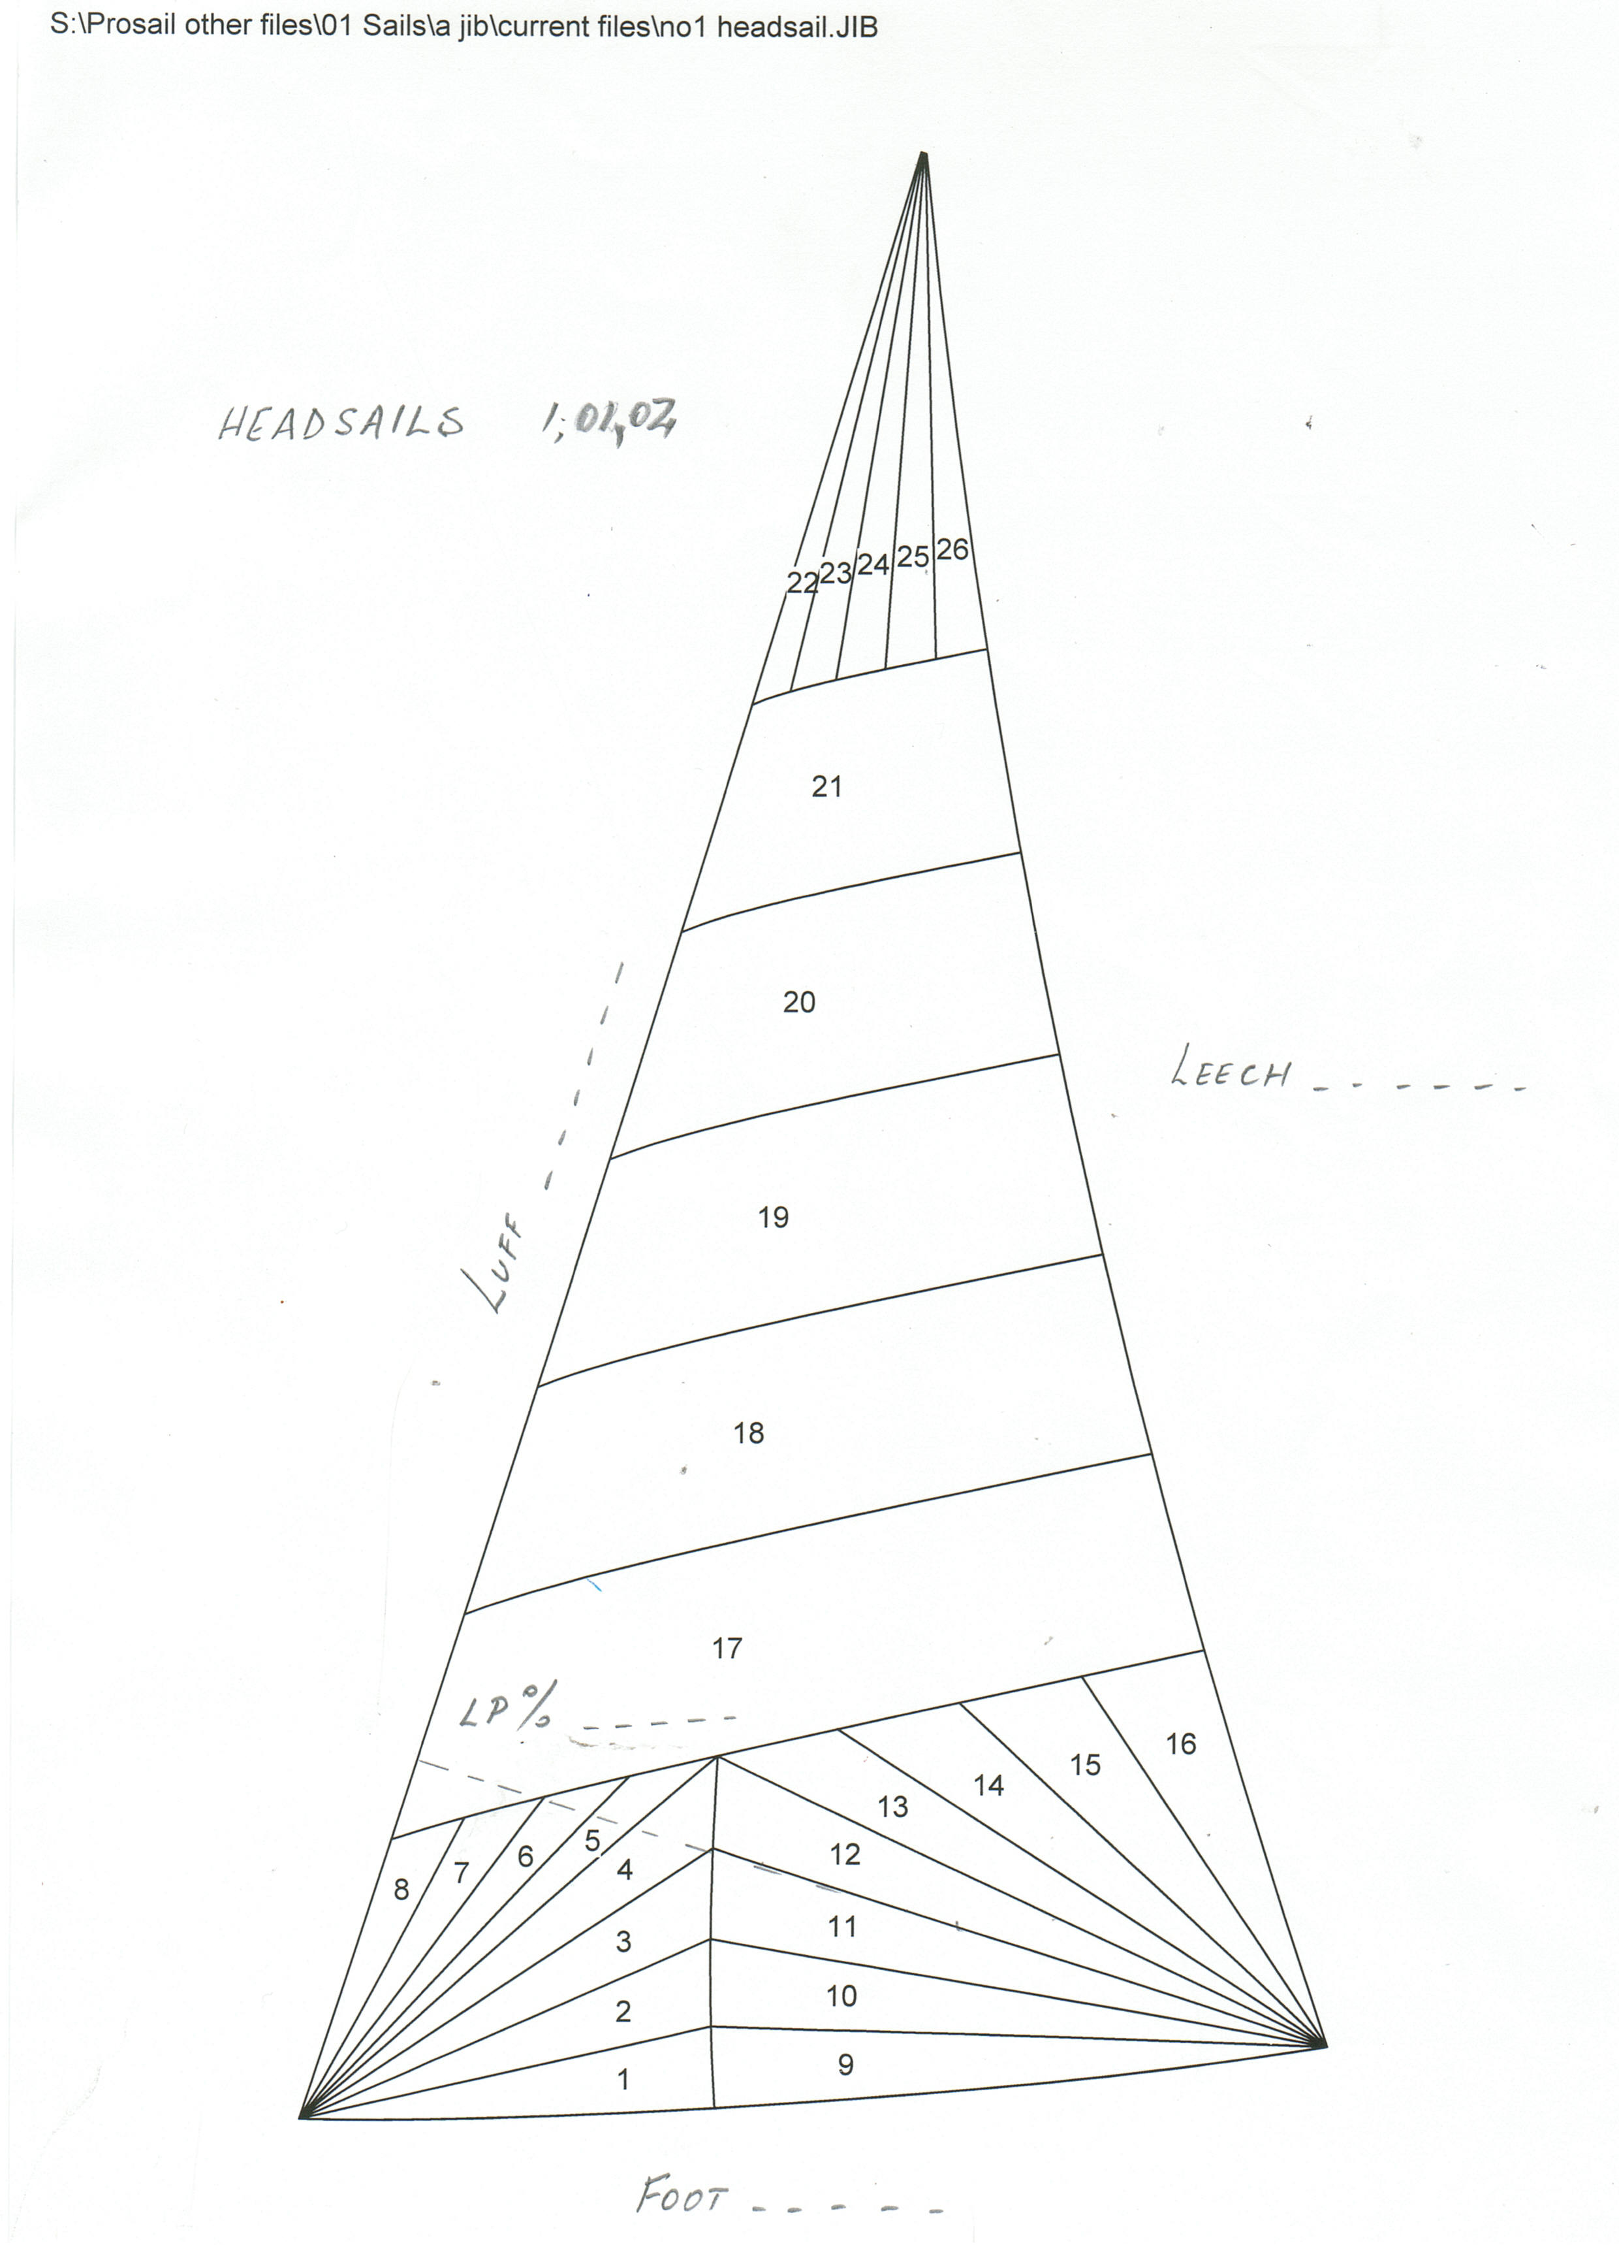

Alegayter Sails Tri-radial Headsail with Vertical Panels Measurement Form
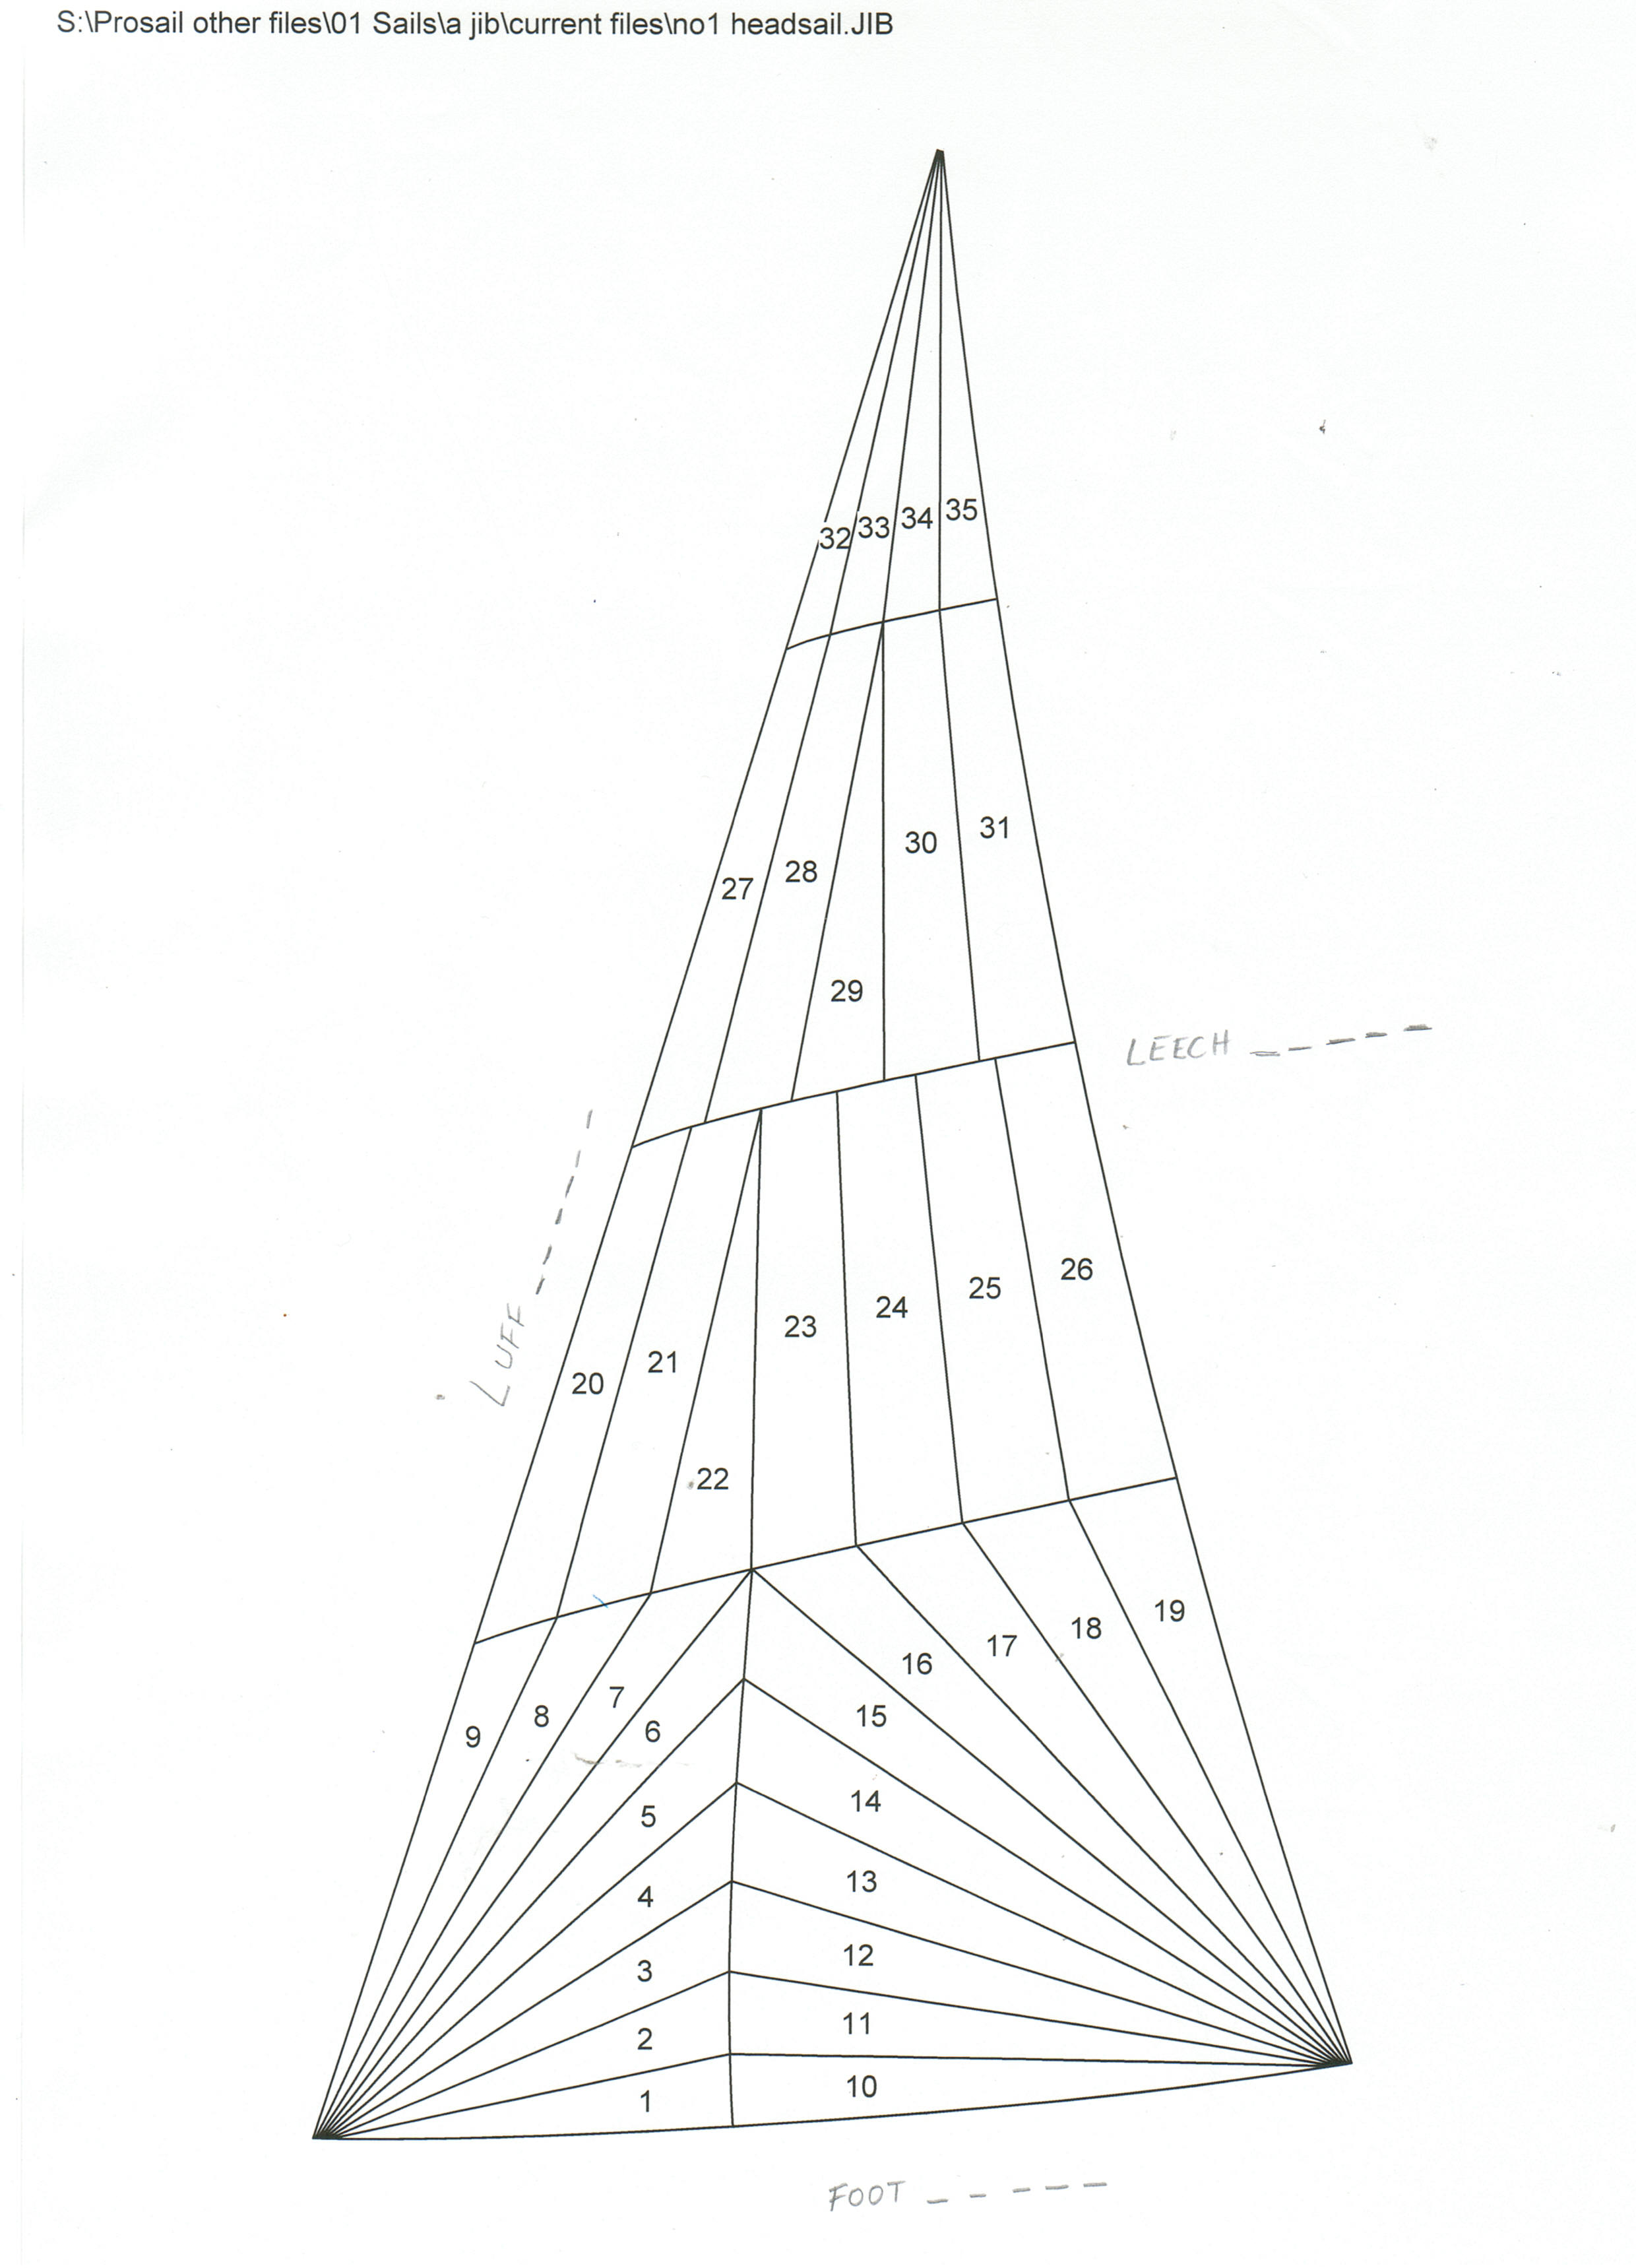
Alegayter Sails Headsail Measurement Form

Name: __________________________________________

Tel: ____________________________________________

Mob: ___________________________________________

Email: __________________________________________

This is for: QUOTE or ORDER (please circle)

Please fax this to us on (08) 8241 0889

OR

Email this as an attachment to us at mail@alegayter.com.au

