Alegayter Sails Boom Bag Measurement Form

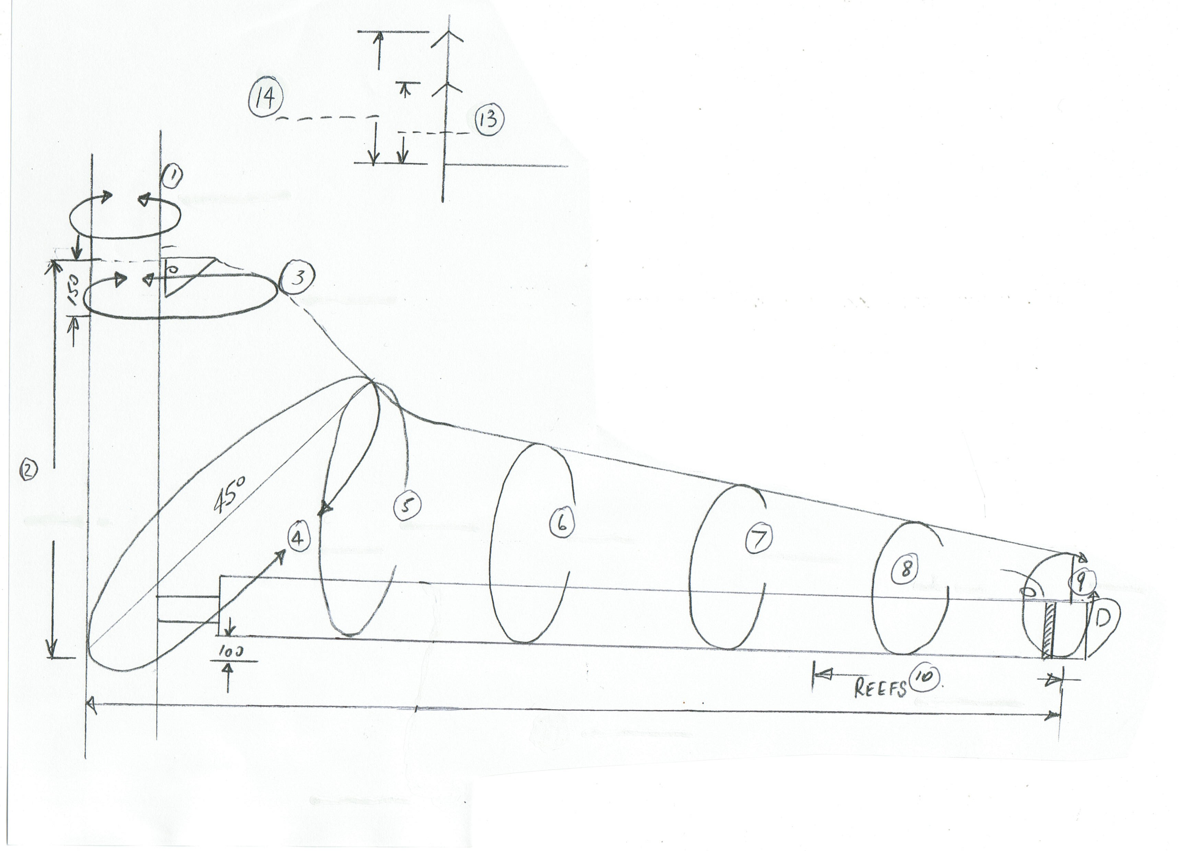
Alegayter Sails Boom Bag Measurement Form

Name: __________________________________________

This is for: QUOTE or ORDER (please circle)

Tel: ____________________________________________

Mob: ___________________________________________

Email: __________________________________________

- Around the mast (include any tracks) ____________ mm.

- Height of cover (headboard to 100mm under boom) ____________ mm.

- 150mm down from head (around sail and mast) ____________ mm.

- From bottom of cover (100mm under boom) at 45° around sail and mast ____________ mm.

- Around sail and boom ( 1 metre back from front of mast) ____________ mm.

- Around sail and boom ( 2 metres back from front of mast) ____________ mm.

- Around sail and boom ( 3 metres back from front of mast) ____________ mm.

- Around sail and boom ( 4 metres back from front of mast) ____________ mm.

- Around sail and boom ( 5 metres back or end of sail, from front of mast) ____________ mm.

- Slit required for all reefs (measure from 50mm past black band to last reef) ____________ mm.

- Size of bolt rope track in boom 8mm or 10mm (please circle) round or flat (please circle)

- Front of mast to 50mm past black band ____________ mm.

Alegayter Sails Boom Bag Measurement Form

For Lazy Jack Lines:

- Height of 1st spreaders (above boom) ____________ mm.

- Height of 2nd spreaders (above boom) ____________ mm.

Additional Boom Bag Features:

- 10/20 removable front section YES / NO (please circle)

- Zippers on outside for boom tent to fence YES / NO (please circle)

- Internal flap to contain bag along the boom for when racing or long distance cruising YES / NO (please circle)

Please fax this to us on (08) 8241 0889

OR

Email this as an attachment to us at mail@alegayter.com.au

